Exercise 2: E-Commerce Platform Search Function
Aim
To implement and analyze Linear Search and Binary Search algorithms for an e-commerce platform and compare their performance using asymptotic notation.
1. Understanding Asymptotic Notation
Big O Notation
Big O notation is used to measure the efficiency of an algorithm by describing how its execution time grows as the input size increases. It helps developers compare different algorithms and choose the most efficient one for a given problem.
Common Big O complexities include:
- O(1) – Constant Time
- O(log n) – Logarithmic Time
- O(n) – Linear Time
- O(n log n) – Linearithmic Time
- O(n²) – Quadratic Time
Big O notation is important because it helps predict algorithm performance when dealing with large amounts of data.
Search Operation Scenarios
Best Case
The required product is found immediately.
- Linear Search: Product found at the first position.
- Binary Search: Product found at the middle position.
Average Case
The product is found after several comparisons.
- Linear Search: Approximately n/2 comparisons.
- Binary Search: Approximately log₂n comparisons.
Worst Case
The product is found at the last position or does not exist.
- Linear Search: n comparisons.
- Binary Search: log₂n comparisons.

2. Setup
Product Class
The Product class represents products available on the e-commerce platform. Each product contains:
- productId
- productName
- category
Product.java
public class Product {
int productId;
String productName;
String category;

public Product(int productId, String productName, String category) {
this.productId = productId;
this.productName = productName;
this.category = category;
}

@Override
public String toString() {
return "Product ID: " + productId +
", Product Name: " + productName +
", Category: " + category;
}
}

3. Implementation
Linear Search Algorithm
Linear Search checks each product one by one until the required product is found.
Code
public static Product linearSearch(Product[] products, int targetId) {
for (Product product : products) {
if (product.productId == targetId) {
return product;
}
}
return null;
}
Working
- Start from the first product.
- Compare the product ID with the target ID.
- If a match is found, return the product.
- Otherwise, continue searching until the end of the array.

Binary Search Algorithm
Binary Search works only on sorted data. It repeatedly divides the search space into two halves until the required product is found.
Code
public static Product binarySearch(Product[] products, int targetId) {
int left = 0;
int right = products.length - 1;

while (left <= right) {
int mid = left + (right - left) / 2;

if (products[mid].productId == targetId) {
return products[mid];
}

if (products[mid].productId < targetId) {
left = mid + 1;
} else {
right = mid - 1;
}
}

return null;
}
Working
- Find the middle element.
- Compare it with the target product ID.
- If the target is smaller, search the left half.
- If the target is larger, search the right half.
- Repeat until the product is found or the search space becomes empty.

Main Program
public class SearchDemo {
public static void main(String[] args) {
Product[] products = {
new Product(101, "Laptop", "Electronics"),
new Product(102, "Mobile", "Electronics"),
new Product(103, "Shoes", "Fashion"),
new Product(104, "Watch", "Accessories"),
new Product(105, "Book", "Education")
}
int searchId = 104;

Product linearResult = linearSearch(products, searchId);

if (linearResult != null) {
System.out.println("Linear Search Result:");
System.out.println(linearResult);
}

Product binaryResult = binarySearch(products, searchId);

if (binaryResult != null) {
System.out.println("Binary Search Result:");
System.out.println(binaryResult);
}
}

public static Product linearSearch(Product[] products, int targetId) {
for (Product product : products) {
if (product.productId == targetId) {
return product;
}
}
return null;
}

public static Product binarySearch(Product[] products, int targetId) {
int left = 0;
int right = products.length - 1;

while (left <= right) {
int mid = left + (right - left) / 2;

if (products[mid].productId == targetId) {
return products[mid];
}

if (products[mid].productId < targetId) {
left = mid + 1;
} else {
right = mid - 1;
}
}

return null;
}
}

4. Output
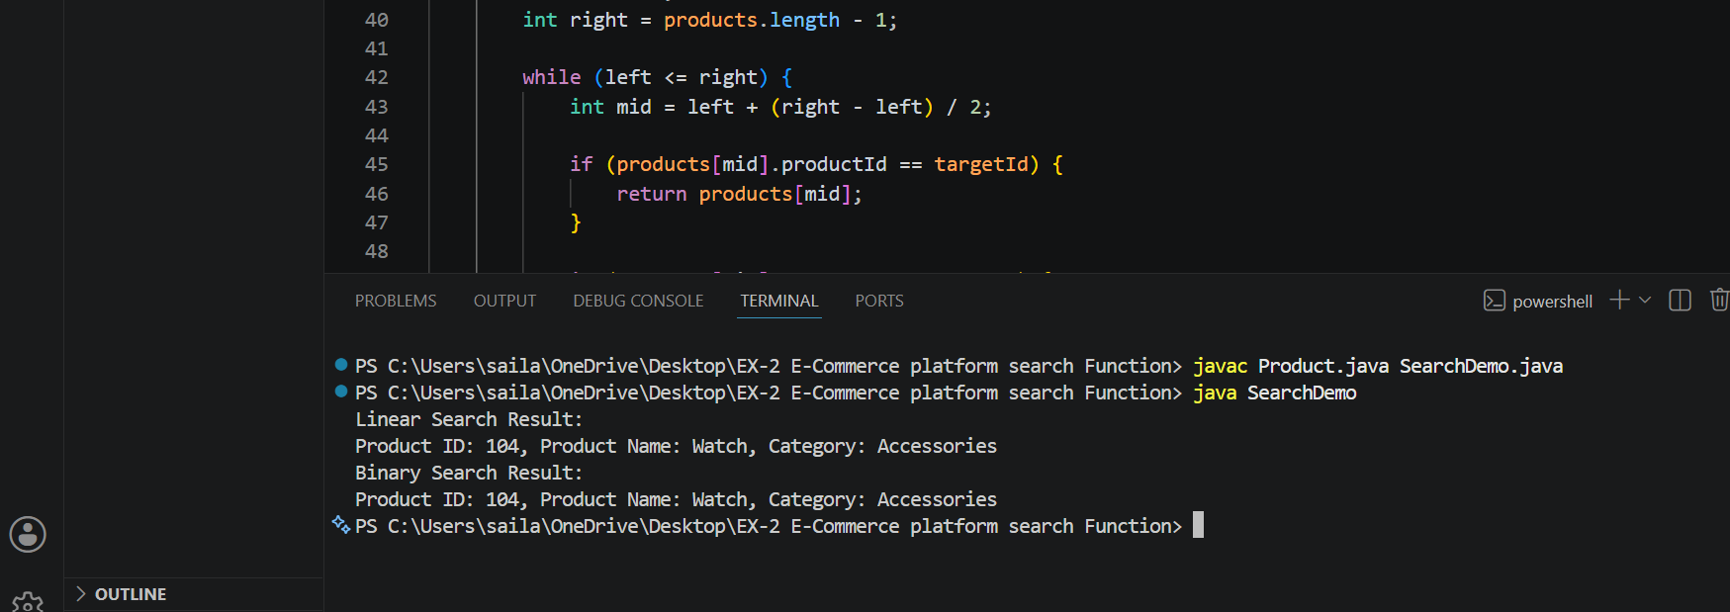
Linear Search Result:
Product ID: 104, Product Name: Watch, Category: Accessories
Binary Search Result:
Product ID: 104, Product Name: Watch, Category: Accessories

5. Analysis
Time Complexity Comparison
Algorithm | Best Case | Average Case | Worst Case
Linear Search | O(1) | O(n) | O(n)
Binary Search | O(1) | O(log n) | O(log n)

Linear Search
Advantages:
- Simple to implement.
- Works on unsorted data.
Disadvantages:
- Slower for large datasets.
- Requires checking many elements.
Binary Search
Advantages:
- Faster search performance.
- Efficient for large datasets.
- Requires fewer comparisons.
Disadvantages:
- Data must be sorted before searching.

6. Practical Purpose
The search feature is an essential component of every e-commerce platform. Customers use it to find products quickly from a large collection of items.
Linear Search is useful when the product list is small or unsorted. Binary Search is more suitable for large product databases because it significantly reduces the number of comparisons required to locate a product.
Real-world applications include:
- Online shopping websites
- Inventory management systems
- Customer record retrieval
- Product catalog management

7. Conclusion
This exercise demonstrated the implementation of Linear Search and Binary Search algorithms for an e-commerce platform. The performance analysis showed that Binary Search is more efficient than Linear Search for large sorted datasets because it has a time complexity of O(log n). Therefore, Binary Search is the preferred choice for modern e-commerce platforms where fast product retrieval is essential for a better user experience.

